Invasive Species Curriculum: Supplemental Material

2018-2019

NEW YORK STATE DEPARTMENT OF ENVIRONMENTAL CONSERVATION

Group:
Day 1 & 2

Invasive Species Research Notes

Notes | Source

Notes | Source

Group:
Day 3

Invasive Species Observations

Species Name | Observation notes | Observation Drawing

Species Name | Observation notes | Observation Drawing

Group name: Class: Date: Day 4

Field Research Form

Student group will choose a location in the class area to survey. This location should be spaced from another group.

Group will survey their location and identify any invasive species in the area. If there are more than one invasive species, the group should choose to focus on one but should record if they saw another invasive or more in the area in the notes section.

Invasive species name
Drawing/sketch
Stem count per 1 m x 1 m
Approximate size of infestation
Infestation is (circle one): | Single | Sparse | Clumped | Saturated

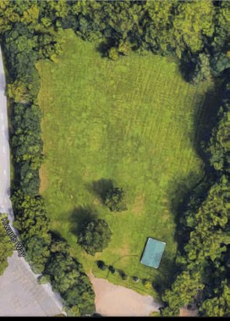
Notes:

Invasive species name
Drawing/sketch
Stem count per 1 m x 1 m
Approximate size of infestation
Infestation is (circle one): | Single | Sparse | Clumped | Saturated

Notes:

Name: Group:
Date: Day 4

Procedure Note Sheet

1.
2.
3.
4.
5.
6.
7.
8.
9.

Name: Group: Day 9
Poster Session Question Prompt Sheet

Question: | Discussion 1: | Discussion 2:
1. What invasive species did
your group find in the field?
2. What can we do in our
everyday lives to prevent the spread of invasive species?
3. What did you learn from
this project?
4. What did you like while
doing the project?
5. How could you continue
research on invasive species following this project?

